Dear Newquay Business
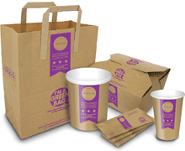
We live in an amazing place. Polystyrene packaging is outdated and severely damaging for our local environment. It’s time to make Newquay polysterene- packaging free and would like to work with you on this for a better, more litter free future for Newquay.
Key facts- Why?
- Polystyrene takes hundreds of years to decompose. It breaks up into small pieces, enters the environment, works its way up the food chain, into the fish that we eat, often killing wildlife along the way.
- The best thing that can happen with polystyrene packaging is that it ends up in landfill. In truth, much of it ends up on the streets, coast and in the sea around Newquay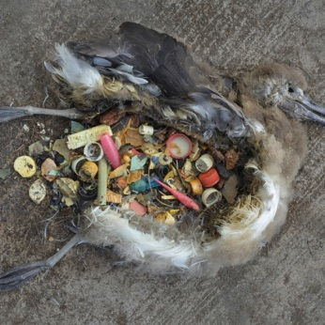 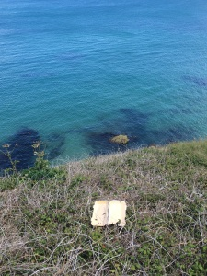 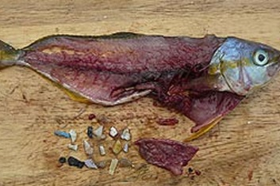 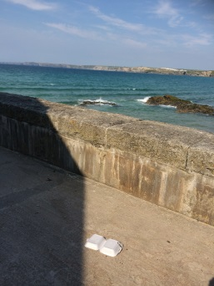
- Our surveys have shown that local consumers are increasingly pro-sustainable packaging and many of Newquay’s leading food outlets already use biodegradable takeaway packaging. Don’t get left behind!
- Cheap alternatives are available- from the local Bookers Cash & Carry- these products can also feature your logo and actually help advertise your business. We are happy to help make it as easy for you as possible and can help source a cheap alternative - compostable plant fibre, cardboard and paper packaging – set up group buying schemes. We have sustainable packaging suppliers on hand that can help. We are a not-for-profit that is happy to help facilitate this transition in any way we can. Get in touch with us at newquaymarinegroup@gmail.com
If you are already using sustainable packaging, We SALUTE YOU! Please let us know so we can give a big shout out to our members, on our website and to other businesses, or get in touch to feature your business on our blog. newquaymarinegroup@gmail.com/ http://newquaymarinegroup.tumblr.com/
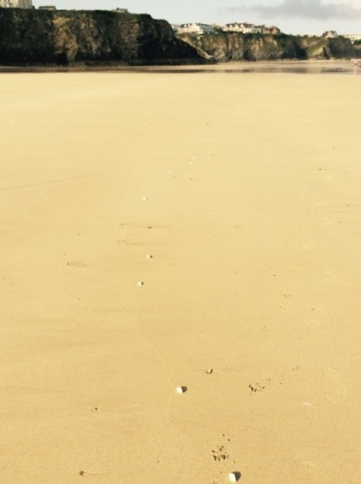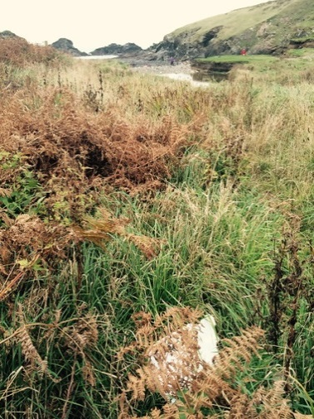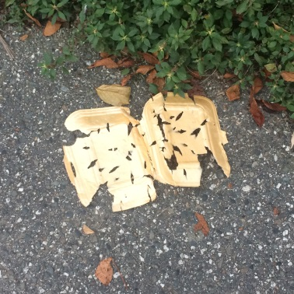
There’s no good argument for continuing to use polystyrene packaging. Your competitors are already onto this.
Be part of the solution. Let’s make a difference together.
With thanks from Newquay Marine Group, Newquay Beach Care and our supporters.
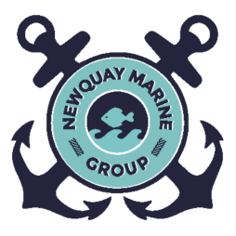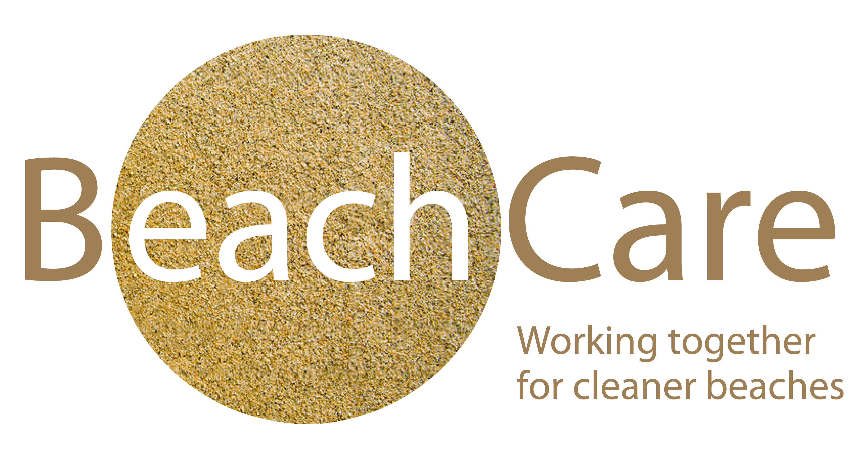
Breakdown of synthetic materials in the environment
